# LM358

LOW POWER DUAL OPERATIONAL AMPLIFIERS:

DESCRIPTION:

These circuits consist of two independent, high gain, internally frequency compensated which were designed specifically to operate from a single power supply over a wide range of voltages. The low power supply drain is independent of the magnitude of the power supply voltage. Application areas include transducer amplifiers, dc gain blocks and all the conventional op-amp circuits which now can be more easily implemented in single power supply systems. For example, these circuits can be directly supplied with the standard +5V which is used in logic systems and will easily provide the required interface electronics without requiring any additional power supply. Inthe linear mode the input common-mode voltage range includes ground and the output voltage can also swing to ground, even though operated from only a single power supply voltage.

PIN CONNECTIONS (top view):

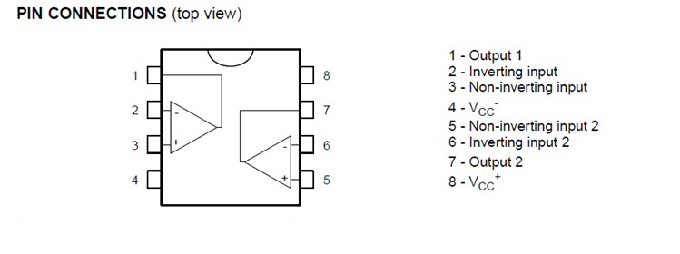

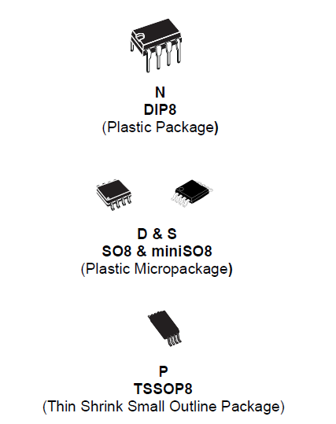

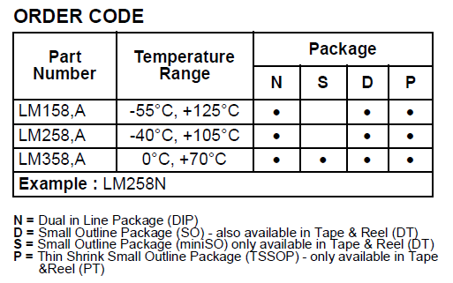

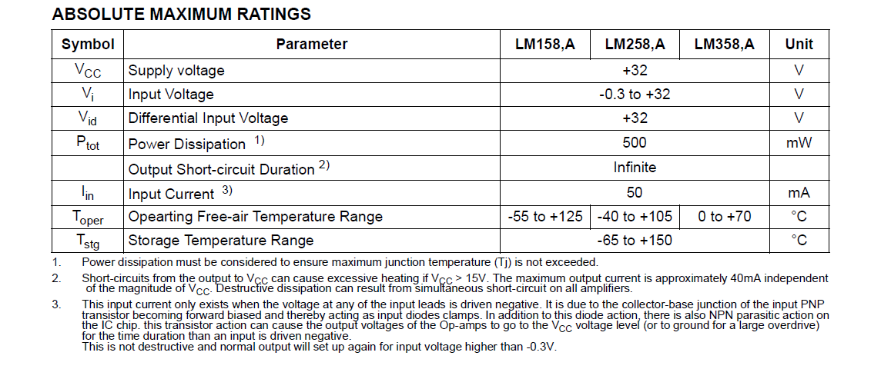

Features:

* INTERNALLY FREQUENCY COMPENSATED
* LARGE DC VOLTAGE GAIN: 100dB
* WIDE BANDWIDTH (unity gain): 1.1MHz (temperature compensated)
* VERY LOW SUPPLY CURRENT/OP (500μA) ESSENTIALLY INDEPENDENT OF SUPPLY VOLTAGE
* LOW INPUT BIAS CURRENT: 20Na (temperature compensated)
* LOW INPUT OFFSET VOLTAGE: 2mV
* LOW INPUT OFFSET CURRENT: 2nA
* INPUT COMMON-MODE VOLTAGE RANGE INCLUDES GROUND
* DIFFERENTIAL INPUT VOLTAGE RANGE EQUAL TO THE POWER SUPPLY VOLTAGE
* LARGE OUTPUT VOLTAGE SWING 0V TO (Vcc - 1.5V)